DISCINOIDS OF MALVINOKAFFRIC REALM: STRATIGRAPHIC AND GEOGRAPHICAL DISTRIBUTION AND SYSTEMATIC REVIEW

DISCINIDEOS DA PROVÍNCIA MALVINOCÁFRICA: DISTRIBUIÇÃO ESTRATIGRÁFICA E GEOGRÁFICA E REVISÃO SISTEMÁTICA

DISCINÓIDOS DE LA PROVINCIA MALVINOCÁFRICA: DISTRIBUCIÓN ESTRATIGRÁFICA Y GEOGRÁFICA Y REVISIÓN SISTEMÁTICA

Abstract: The main theme of the article is the systematic review of discinoids the Lower to Middle Devonian of the Ponta Grossa (latest Pragian to early Emsian) and São Domingos Formation (late Emsian to Frasnian), Paraná Basin, Paraná state, Brazil. Five discinoid species were recorded: Orbiculoidea baini, O. bodenbenderi, O. excentrica, Gigadiscina collis, and Rugadiscina stagona. The adopted the reallocation of Gigadiscina collis instead of Orbiculoidea collis, proposed by Mergl; Massa (2005), the maintenance of other species as well as new description data are accepted. Description of Rugadiscina stagona a new species of discinoid for the Devonian of the Paraná Basin.
Key words: Orbiculoidea. Rugadiscina. Gigadiscina. Discinoids. Devon.

Resumo: O tema principal do artigo é a revisão sistemática dos discinóides do Devoniano Inferior ao Médio do Ponta Grossa e da Formação São Domingos (Emsian tardia ao Frasniano), Bacia do Paraná, Paraná, Brasil. Foram registradas cinco espécies discinoides: Orbiculoidea baini, O. bodenbenderi, O. excentrica, Gigadiscina collis e Rugadiscina stagona. A adotada a reatribuição de Gigadiscina collis em vez de Orbiculoidea collis, proposta por Mergl; Massa (2005), a manutenção de outras espécies, bem como novos dados de descrição são aceitos. Descrição de Rugadiscina stagona uma nova espécie de discinoides para o Devoniano da Bacia do Paraná.
Palavras-chave: Orbiculoidea. Rugadiscina. Gigadiscina. Discinídeos. Devoniano.
Resumen. El principal objetivo del artículo es la revisión sistemática de discinídeos del Devoniano Inferior al Medio de las Formaciones Ponta Grossa (Pragiano superior a Emsiano inferior) y São Domingos (Emsiano Superior a Frasniano) de la Cuenca de Paraná, Estado de Paraná, Brasil. Son identificadas cinco especies: Orbiculoidea baini, O. bodenbenderi, O. excentrica, Gigadiscina collis, y Rugadiscina stagona. Es adoptada la reasignación de Gigadiscina collis en lugar de Orbiculoidea collis, propuesta por Mergl; Massa (2005), el mantenimiento de otras especies, así como nuevos datos descriptivos son aceptados. Descripción de Rugadiscina stagona una nueva especie de discinoide para el Devónico de la Cuenca de Paraná.
Palabras clave. Orbiculoidea. Rugadiscina. Gigadiscina. Discinídeos. Devoniano.

INTRODUTION

Orville A. Derby first time mentioned the occurrence of Devonian organophosphatic discinoids brachiopods (Family Discinidae) from the Paraná Basin in 1877 (Paraná State, South of Brazil). In the Paraná Basin, Clarke (1913), Kozlowski (1913) and Lange (1943) conducted taxonomic studies of group. The first taxonomic studies of the group in the Paraná Basin were conducted by Clarke (1913) recognized Orbiculoidea baini Sharpe (1856) and described two new species: Orbiculoidea bodenbenderi and Orbiculoidea collis. In the same year, Kozlowski (1913) described Orbiculoidea grandissima. However, this species appears to have the same characteristics as the formerly published O. collis, and may be a junior synonym. John M. Clarke did not participate in any of the field campaigns in Brazil but he noticed, by careful observations, that the fossils exhibited a cosmopolitan character independent of the sedimentary facies in which they occurred.
This characteristic is unique among the discinoids recorded from the Ponta Grossa and São Domingos Formations (lithostratigraphy of GRAHN; MENDLOVICZ MAULLER; BERGAMASCHI, 2013); this means that this fossil group occurs in all fossiliferous assemblages, regardless of their associated facies. Lange (1943) was the other author who described a discinoid, (O. excentrica) from the Devonian of Brazil. Subsequent authors referred to the group only in generic terms. The present paper is focused to taxonomy and revision of already described discinoids, but new paleoecological, stratigraphical and geographical data are presented. The study confirms the relocation of Orbiculoidea collis to Gigadiscina collis proposed by Mergl; Massa (2005), as well as the maintenance of Clarke's (1913) and Lange's (1943) discinoids species and the recognition of a new specie (Rugadiscina stagona) to the Devonian of the Paraná Basin, Brazil.

MATERIALS AND METHODS

Part of the fossil material analyzed for the present research was already deposited at the UEPG fossil collection; nevertheless, new field campaigns were implemented. The UEPG fossil material had no reference to bedding plane, stratigraphical position, and lithological or sedimentological data. These specimens were especially useful for the systematic revision. However, the new material collected allowed a more comprehensive analysis, which led to some additional information.
The collected samples belong to the following localities: Ponta Grossa (outcrops Boa Vista (25⁰ 04’ 38,01” S; 50⁰ 11’ 25,01” W), Vendrami (25⁰ 08’ 57,07” S; 50⁰ 11’ 25,01” W), Desvio Ribas - Tibagi (25⁰ 12’ 02,73” S; 50⁰ 03’ 58,55” W), Caça e Pesca (25⁰ 11’ 24,15” S; 50⁰ 08’ 27, 36” W), Fazenda Rivadávia (25⁰ 15’ 05,47” S; 50⁰ 03’ 06,2” W), Curva I (25⁰ 03’ 34,56” S; 50⁰ 08’ 04,09” W), Curva II (25⁰ 04’ 03,06” S; 50⁰ 07’ 56,18” W), Vila Francelina (25⁰ 04’ 55” S; 50⁰ 06’ 54” W), Pilão de Pedra (25⁰ 05’ 17,95” S; 50⁰ 09’ 15,43” W) and Vila Vilela (25⁰ 05’ 17,40” S; 50⁰ 09’ 16,37” W). Jaguariaíva city (railroad outcrop Jaguariaíva-Arapoti (24⁰ 14’ 05” S; 49⁰ 42’ 34” W). Tibagi city (outcrops Tibagi II (24⁰ 29’ 51” S; 50⁰ 25’ 00” W), Furnas/Ponta Grossa contact (24⁰ 46’ 04” S; 50⁰ 09’ 24” W), Sítio Wolff (24⁰ 28’ 11,21” S; 50⁰ 32’ 08,46” W), Fazenda Fazendinha (24⁰ 28’ 04,50” S; 50⁰ 26’ 28,01” W), Km 211 (24⁰ 34’ 29,19” S; 50⁰ 27’ 05,03” W), Km 217 (24⁰ 36’ 34,88” S; 50⁰ 26’ 37,73” W) and Km 220 (24⁰ 38’ 02,19” S; 50⁰ 27’ 40,35” W) of the BR 153 highway and Fazenda Zezito = Tibagi Member type section sensu Lange; Petri, 1967 (24⁰ 31’ 32,65” S; 50⁰ 27’ 52,05” W). Palmeira city (Rio Caniú outcrop (25⁰ 18’ 48” S; 50⁰ 05’ 32” W).
GEOLOGY OF THE STUDY AREA

The Paraná Basin is an intracratonic, intercontinental and polycyclic sedimentary basin. It has an area of 1.5 million square kilometers (MILANI; MELO; SOUZA, 2007). This basin has two depocenters, the Alto-Garças sub-Basin (to north) and the Apucarana sub-basin (to south), which constitute the middle portion of the South American continent. Milani et al., (2007) recognized six major rock packages that represent depositional periods of few millions of years. These units are limited by inter-regional discontinuities. The Paraná supersequence (Devonian), which bears the discinoids of this study, is represented by successive transgressive-regressive cycles that are linked to sea level oscillations (MILANI; MELO; SOUZA, 2007). The outcrops are a part of the Campos Gerais Group (Figure 1), comprising from bottom to top the Furnas, Ponta Grossa, and São Domingos Formations (the last Formation including the Tibagi Member) (GRAHN; PEREIRA, BERGAMASCHI, 2000; GAUGRIS; GRAHN, 2006; GRAHN; MENDLOWICZ MAULLER; BERGAMASCHI, 2013; MENDLOWICZ MAULLER; GRAHN; MACHADO CARDOSO, 2009) A regional gap is recorded during the latest early Emsian and the earliest late Emsian, as a result from the Andean Pre-Cordillera epeirogenesis (GRAHN; MENDLOWICZ MAULLER; BERGAMASCHI, 2013). The Ponta Grossa sits on the Furnas Formation. Lithologically is composed of black shales to light gray, dark mudstones massive or laminated siltstones and, interspersed with sandy layers or sand lenses, with wave ripples or hummocky cross-stratification (GRAHN; MENDLOWICZ MAULLER; BERGAMASCHI, 2013), and trace fossils. Deposits of marine shoreface to offshore in transgressive context characterize this unit, since the contact the Furnas formation (BERGAMASCHI; PEREIRA, 2001). The São Domingos Formation is positioned stratigraphically above the Ponta Grossa Formation. The São Domingos Formation is composed of mudstones, shales, siltstones, sandstones and conglomeratic sandstones. These rocks record marine deposits of the inner and outer shelf.

Figure 1. Geological map of the study area (after Grahn et al. 2013).

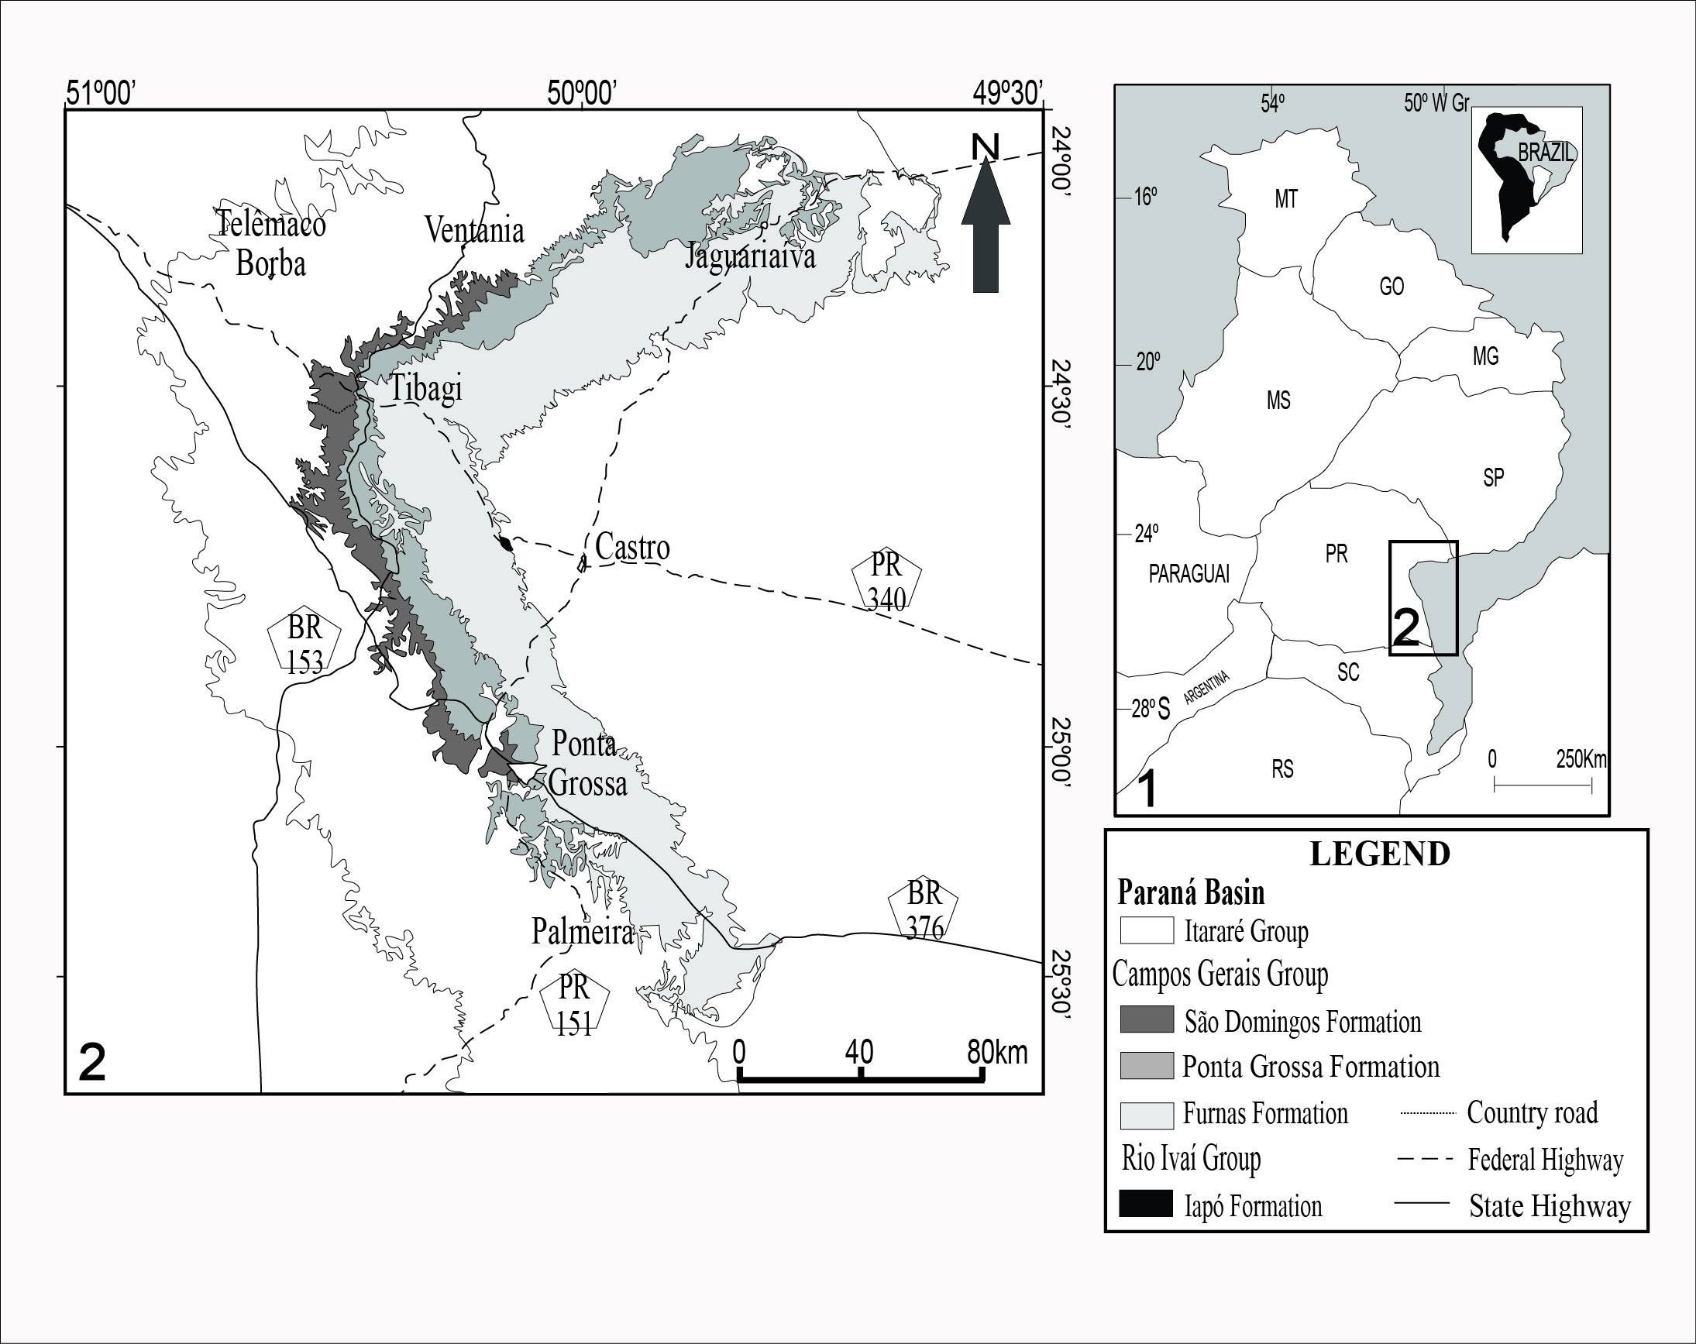
SYSTEMATIC PALEONTOLOGY

We analyzed 957 samples and about 3,500 discinoid specimens. The fossils were collected from Devonian outcrops, and they are currently deposited at the Laboratório de Paleontologia e Estratigrafia, Departamento de Geociências, Universidade de Ponta Grossa (DEGEO- UEPG).

Order Lingulida Waagen, 1885
Superfamily Discinoidea Gray, 1840
Family Discinidae Gray, 1840
Genus Gigadiscina Mergl; Massa, 2005

Type species. Gigadiscina lessardi. Lower Devonian, Pragian (Siegenian); Tamesna Basin, Algeria.

Gigadiscina collis Clarke, 1913
Figure 2.1-2.2
1913 Orbiculoidea collis Clarke, p. 306, pl. 25, figs 23−26
1925 Orbiculoidea (Roemerella) cf. collis Reed, p. 36, pl. 4, fig. 9a
1985 Orbiculoidea collis Melo, p. 59−60, fig. 5−8
2005 Gigadiscina collis (Clarke, 1913), Mergl; Massa, 2005, p. 400, fig. 2
2010 Orbiculoidea collis, Comniskey; Bosetti, p. 31.

Material. Material MPI 97, 698, 1623, 3021, 5001, 5005, 5555, 5767, 5871, 5781, 5976, 6145 and 6148.
Emmended diagnosis. The shell is sub-triangular in outline. The shell is large, with the length measures 60 mm and width 50 mm. They are approximately 30 rugellae per specimen. The rugellae are separated by interspaces about 1 to 3 mm distance between each rugellae. There are 7 to 9 rugellae per 5 mm in the anterior part of the shell. The thickness of rugellae is 1 mm in the dorsal and ventral valves. The rugellae, both externally, are smooth on the dorsal valve in comparison to the ventral valves. Attachments of the adductor scars can be present.
The dorsal valve (Fig. 2.2) is high, strongly convex and sub-conical. Apex is strongly acuminate and pointed towards the posterior margin; prominent beak is present. The posterior region declines gently towards the anterior region and forms an angle of 35⁰ to the commissural plane. The anterior slope is slightly concave.
The ventral valve is slow and flat. The ventral valve (Fig. 2.1) has apical region elevated. The pedicle notch is closed and weakly defined, and occupies 26% the length of the shell (occupying one thirds of the posterior slope). Concentric and very fine rugellae, with interspaces of 1 mm. The posterior slope is slightly convex to flat. Anterior slope is slightly concave.
Remarks. Orbiculoidea collis was first described and proposed by Clarke (1913). Orbiculoidea has reduced size, thick and low rugellae, slightly elevated dorsal valve, and slightly inclined apex. Sub-circular outline is flat, ventral valve has a long pedicle notch. Biconvex shell is present. The taxonomic analysis of Clarke’s (1913) type material showed that O. collis is strikingly different in comparison with other Orbiculoidea species. O. collis has fine and tall rugellae, conical and convex dorsal valve, sub-central apex, sub-triangular outline and a flat ventral valve. Mergl; Massa’s (2005) description of the species is consistent with the samples studied here. Orbiculoidea collis is a species that departs, in a morphological sense, from the original description of the genus. The analysis of the Paraná Basin fossil material afforded the reallocation from Orbiculoidea collis to Gigadiscina collis, proposed by Mergl; Massa (2005). The specie O. grandissima (KOZLOWSKI, 1913) is, apparently, the same species addressed by Clarke (1913). However, we have not reviewed Kozlowski’s (1913) original fossil material and, for this reason, we chose to maintain this as a valid species, until a revision is made possible.
Geographic and stratigraphic provenance. Brazil (Ponta Grossa Formation, Apucarana sub-Basin) and Argentina (Ansilta Formation). Latest Pragian to Emsian.

Figure 2. Gigadiscina collis. 1, ventral valve, external mould, MPI 5005. 2, dorsal valve, external mould, MPI 5555.
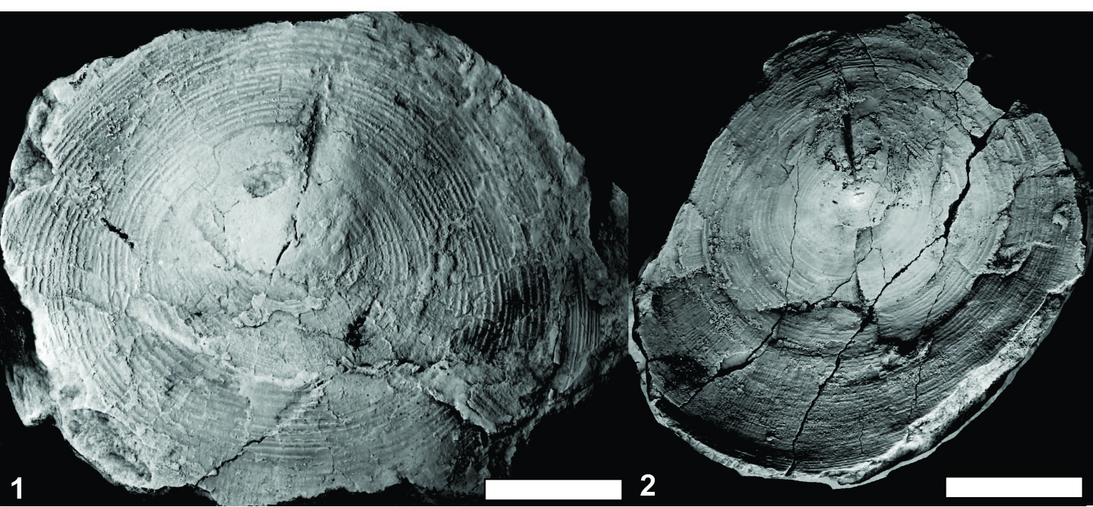

Genus Orbiculoidea D’ Orbigny, 1847
Type species. - Orbicula forbesii Davidson, 1848
Orbiculoidea baini Sharpe, 1856
Figure 3.3-4, 4.5

1856 Orbicula bainii Sharpe, 1856, p. 210, pl. 26, figs. 20 - 23
1903 Orbiculoidea baini Reed, 1903, p.168, pl. 20, figs. 4 -5
1913 Orbiculoidea baini Clarke, 1913, p. 301, pl. 25, figs. 5 - 15
1913 Orbiculoidea baini Kozlowski, 1913, p. 8-108, pl. 1, figs. 11-13
1925 Orbiculoidea (Roemerella) baini Reed, 1925, p. 36 - 38
1985 Orbiculoidea baini Melo, 1985, p. 48-57, fig. 1 - 2
1991 Orbiculoidea baini Figueiras, 1991, p. 57 - 64
2001 Orbiculoidea falklandensis Boucot et al., 2001, p. 111, pl. 2, figs. 1-17
2011 Orbiculoidea baini Comniskey, 2011, pp. 182, pl. 4 - 7

Material. MPI 635, 1728, 1837, 5025 - 5028, 5218, 5705, 5755, 5921, 5945 and 5975.
Emmended diagnosis. The shell has a circular to sub-circular outline, with width varying from 10 to 29 mm. The rugellae are concentric and separated by interspaces with 0.4 to 0.9 mm distance between each rugellae. The thickness of rugellae is 0.5 mm. There are approximately 24 rugellae per specimen. There are 8 to 10 rugellae per 10 mm in the anterior part of the shell.
The dorsal valve is lightly concave. The apex of the dorsal valve (Fig. 4.5) is slightly shifted towards the posterior slope. On the internal mold, rugellae are almost imperceptible, though spaced regularly with small interspaces. On the external mold the rugellae are more pronounced and spaced regularly with small shallow interspaces. The posterior slope is slightly convex and forms an angle of 80⁰ to the commissural plane. The anterior slope is weakly concave.
The ventral valve is flat, (Fig. 3.3, 4) with marked concentric rugellae with wide interspaces. The pedicle opens behind the apical region and has half of its length (occupies 50% of the shell). A callosity is observed at the beginning of the pedicle in some specimens. The posterior and anterior slope is plan.
Remarks. Orbiculoidea baini differs from O. bodenbenderi and O. excentrica in having noticeable rugellae and larger interspaces. Another difference is the circular shell outline and smaller dimensions of O. baini. The pedicle notch has a greater size and it is robust, occupying half the valve diameter. O. bodenbenderi has a smaller notch, which is restricted to the valve apex. In O. excentrica the pedicle notch does not extend to half of the valve diameter. The species Orbiculoidea baini differs from Orbiculoidea saltensis (REED, 1927) to present rugellae strongly marked, large interspaces, pedicle notch is robust and occupying half the valve diameter and the dorsal valve is less concave and less high than O. saltensis.
Unlike to Lech (2011), the present authors don’t accept the allocation of genus O. baini for G. baini. All specimens analyzed in the Paraná Basin, showed smaller sizes of shell if compared to Gigadiscina (Mergl; Massa, 2005) and the specimen O. baini have the pedicle track higher than the representatives of the genus Gigadiscina. The dorsal valve is less concave and the dorsal apex is more central in O. baini than in Gigadiscina. The anterior slope in Gigadiscina it’s almost double the posterior slope, whereas in O. baini the anterior and posterior slope having substantially the same size. O. baini also differs from O. falklandensis by presenting a low dorsal valve; the apex in O. baini is more subcentral than in O. falklandensis and the rugellae are thicker in O. baini.
Geographic and stratigraphic provenance. Brazil (Ponta Grossa and São Domingos Formation, Apucarana sub-Basin; Unit 4, Alto Garças sub-Basin), South Africa, Argentina, Bolivia and Uruguay. Latest Pragian to early Givetian.

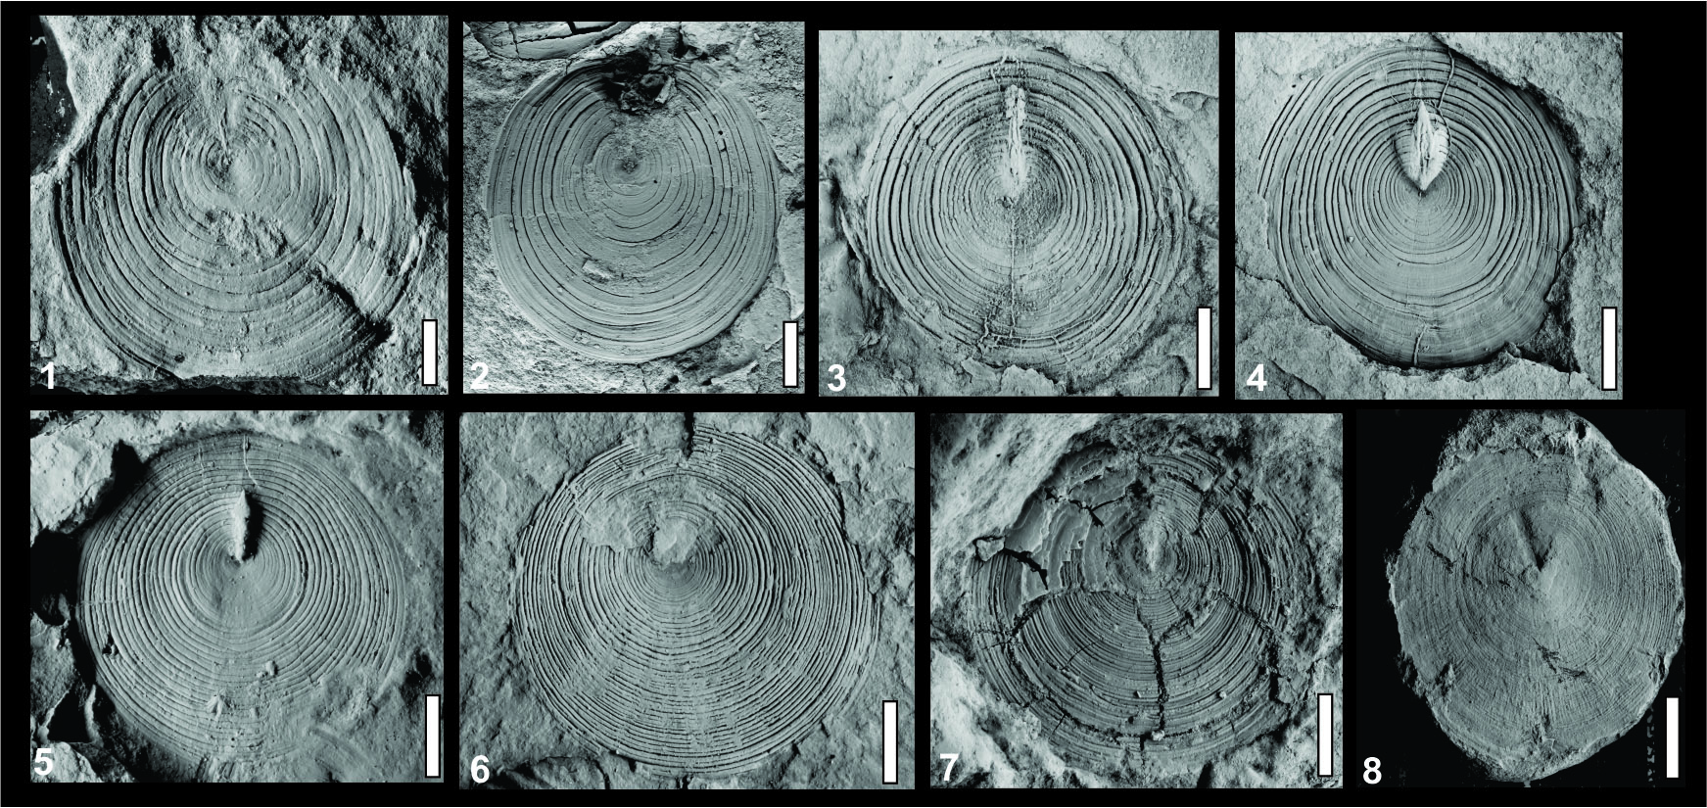
Figure 3. Rugadiscina stagona sp nov, 1-2, ventral valve, external mould, MPI 6104; ventral valve, external mould, MPI 10881. Orbiculoidea baini, 3-4, ventral valve, external mould, MPI 5705 and ventral valve, external mould, MPI 1728. Orbiculoidea excentrica, 5-6, ventral valve, external mould, MPI 5762 and dorsal valve, MPI 10882. Orbiculoidea bodenbenderi, 7-8, ventral valve, internal mould, MPI 6125 and ventral valve, internal mould, MPI 5485.
Orbiculoidea bodenbenderi Clarke, 1913
Figure 3.6-3.7, 4.3

1913 Orbiculoidea bodenbenderi Clarke, 1913, p. 306, pl. 25, figs 16-22
1954 Orbiculoidea bodenbenderi Lange, 1954, p. 41
1985 Orbiculoidea bodenbenderi Melo, 1985, p. 58, figs. 3-4
2011 Orbiculoidea bodenbenderi Comniskey, 2011, pp. 182, pl. 8-10

Material. MPI 639, 5122, 5123, 5274, 5317, 5861, 5485, 5755, 5758, 5759, 6125, 10148.
Emmended diagnosis. Shell outline is sub-circular with a thinning at posterior margin. The shell is large, with the length 25 mm and width 25 mm. The rugellae (thickness is about 0.4 mm) are smooth, concentric, slightly elevated, and spaced regularly with occasional irregular spacing and small interspaces. The thickness of interspaces measures from 0.3 to 0.6 mm. There are approximately 23 to 43 rugellae per specimen or there are found 12 to 15 rugellae per 5 mm in the anteromedian part of the shell.
The dorsal valve is slightly elevated and conical, and has a subcentral apex nearer to the posterior margin. The posterior slope is slightly convex and forms an angle of 75⁰ to the commissural plane. The posterior slope is weakly convex and the anterior slope is concave.
The ventral valve is planar (Fig. 3.6-3.7). At the ventral valve, the rugellae are very neat and elevated. The pedicle notch is small (Fig. 4.3). The pedicle track occupies 29% of length of the shell (about one third of the shell).
Remarks. The shell is regularly spaced concentric and clearly elevated rugellae with no differences in either valve is the feature that distinguishes O. bodenbenderi from O. bainii. In adult specimens of O. bodenbenderi, the pedicle track is very short and small, and restricted to the apex. It differs from the other species, which have larger pedicle notches that occupy half of the shell’s total length. Orbiculoidea bodenbenderi differs from O. saltensis and O. falklandensis for presenting their rugellae and interspaces with smaller thickness, a short pedicle track and a sub-central apex. Lech (2011) proposes the allocation of O. baini and O. bodenbenderi to Gigadiscina baini and Gigadiscina bodenbenderi, however, after reviewing O. bodenbenderi and O. baini specimens of the Paraná Basin, the present authors don’t accept such allocation genus, because was verified differences that don’t allow the allocation of genus, such as: the dorsal valves in O. baini and O. bodenbenderi are lower than in representatives of the genus Gigadiscina. The apex in O. bodenbenderi is slightly concave and turned the posterior slope, whereas in Gigadiscina the apex is strongly concave. The pedicle track in O. bodenbenderi is short and narrow, while in Gigadiscina the pedicle track is larger, occupying 35% of length of the shell.
Geographic and stratigraphic provenance. Paraná State, Paraná Basin, Brazil. Latest Pragian to early Eifelian.

Orbiculoidea excentrica Lange, 1943
Fig. 3.5-6, 4.1- 2

1943 Orbiculoidea excentrica Lange, 1943, p.223, pl. 17, p. 1
1985 Orbiculoidea excentrica Melo, 1985, p. 61, p. 1
2011 Orbiculoidea excentrica Comniskey, 2011, pp. 182, pl. 11

Material. MPI 631, 5317, 5762, 6007 and 10882.
Emmended diagnosis. The shell has a sub-circular outline and a flat lateral profile. The shell has a maximum of 20 mm of width and 21 of length. There are approximately 36 rugellae per specimen. The rugellae thickness is about 0.5 mm. The rugellae are separated by interspaces with 0.1 to 0.2 mm distance between each rugellae. There are 10 to 15 rugellae per 5 mm in the anteromedian part of the shell.
The dorsal valve is slightly elevated; apex towards the posterior margin, and beak is more prominent than the other species (Fig. 4.1- 4.2). This species presents a greater apex displacement, which makes the shell more elongated throughout the anterior region. External and internal molds have irregularly spaced growth lines and small interspaces. The anterior region is somewhat inclined, and there is a site with a greater number of rugellae. The posterior slope also presents a slight inclination towards the beak. The posterior slope is slightly convex and forms an angle of 62⁰ to the commissural plane.
The ventral valve is flat. The pedicle notch begins nearer to the posterior margin and its very short, smooth and thin (Fig. 3.5-3.6). The proximal portion of the notch sometimes displays a callosity. The pedicle track occupies 16% of the length of the shell. The anterior and posterior slope is plan.
Remarks. Lange (1943) described this new species from only one available ventral valve. The species was recorded at the transitional beds of the lower Ponta Grossa Formation (PETRI, 1948). The region that surrounds the pedicle notch is a little depressed. Distinct but irregularly spaced rugellae ornament the shell. The rugellae are bifurcate near the anterior region. Interspaces are small at the posterior region and relatively large at the anterior region. The pedicle track is completely closed, relatively short, and restricted to the apical region. According to Lange (1943), similarities between O. excentrica and O. baini appear only at the younger stages until the rugellae bifurcation appears; from this stage onwards the O. excentrica shell differs in being extremely irregular. The dorsi-ventral compression is a common taphonomic signature in discinoids; in the work beginning it’s suspected that O. excentrica was a taphonomic artifact of O. baini. Lucas (2001) proposed the term taphotaxon to define taxa that suffer morphological alterations due to taphonomic processes, displaying a distinct morphology formed by diagenetic processes. However, this isn’t the case with O. excentrica, as the characteristics observed by Lange (1943) are evident in a series of samples from several stratigraphic levels, and in several ontogenetic phases. O. excentrica differs from other discinoid species cited herein especially by its rugellae disposition, which are fewer in the posterior margin in O. excentrica but constant in numbers throughout their shells in other species. The shell outline is also different when compared to the other species: it has a more acuminated posterior margin than the anterior.
The specie O. excentrica differs from O. saltensis and O. falklandensis for possessing a shell more elongate and has the pedicle track shorter and more close to the posterior margin than O. saltensis. The dorsal valve in O. excentrica is more conspicuous and its apex is sub-central. Another notable feature is the rugellae in O. excentrica are closer together at the posterior margin, with a smaller interspace between them.
Geographic and stratigraphic provenance. Brazil (Ponta Grossa and São Domingos Formation, Apucarana sub-Basin; Unit 4, Alto Garças sub-Basin). Latest Pragian to early Givetian.

Rugadiscina stagona sp.nov.
Fig. 3.1-2, 4.4
Derivation of name. Tear drop = in latim, stagona
Material. Holotype – MPI 6162, Paratype MPI 5122, 5730, 6163, 6104 and 10881.
Diagnosis. Presents a Convexoplane outline. The shell has a maximum of length of 29 mm and 30 mm of width. They are approximately 18 to 20 rugellae per specimen. The rugellae thickness is about 0.8 mm. The rugellae are separated by interspaces with 0.8 to 1.8 mm distance between each rugellae. There are 6 to 8 rugellae per 5 mm in the anteromedian part of the shell.
Dorsal valves are oval with very closely rugellae and small and shallow interspaces. The apex is small, conspicuous, and faces the posterior region (Fig. 4.4). They were not found external molds of dorsal valve.
Ventral valves have a circular outline; rugellae and interspaces are broadly separated (Fig. 3.1). The pedicle track is thin and occupies about 20 % of the length of the shell. All of the above cited features exclude these specimens from Orbiculoidea and justify assignment to a separate genus.
Remarks. All of the above cited features exclude these specimens from Orbiculoidea and justify assignment to a separate genus. Rugadiscina sp. is a British Silurian genus. More data, samples and field campaigns are necessary to corroborate the presence of this genus or even the proposition of a new one at the Devonian of the Paraná Basin.
Geographic and stratigraphic occurrence. Paraná State, Paraná Basin, Brazil. Silurian. England. Early Emsian.

Figure 4. Orbiculoidea excentrica, 1, dorsal valve, internal mould, MPI 5945. Orbiculoidea bodenbenderi, 2, 7-9, dorsal valve, external mould, MPI 10148; apex of the dorsal valve, MPI 5755; rugellae with scale of 500 µm; ventral valve, MPI 5122. Rugadiscina stagona sp nov., 3, dorsal valve, internal mould, MPI 5759. Orbiculoidea baini, 4-6, 10, robust pedicle in O. baini; rugellae with scale of 200 µm; rugellae with scale of 500 µm and dorsal valve, MPI 5345.
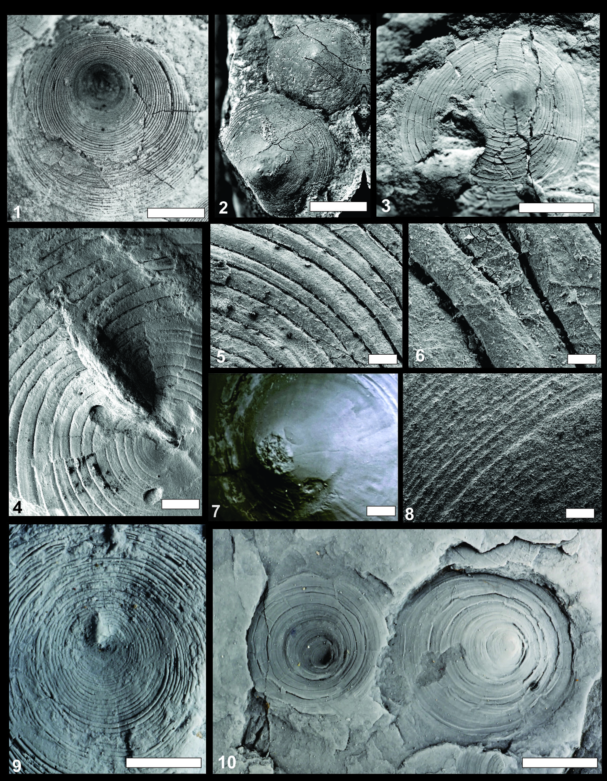

STRATIGRAPHY AND GEOGRAPHICAL DISTRIBUTION OF DISCINOIDS OF MALVINOKAFFRIC REALM

Orbiculoidea had a wide geographical distribution during the Brazilian Devonian, being recorded in the Paraná, Parecis, Amazonas and Parnaíba Basins (CLARKE, 1913; LANGE, 1943; MELO, 1988; BOUCOT et al., 2001). Gigadiscina (= Orbiculoidea collis sensu: CLARKE, 1913; LANGE, 1954; MELO, 1988; BOUCOT et al., 2001) however, was only recorded in the Paraná and Parecis Basins, and Rugadiscina only in the Paraná Basin.
According to the field data and recent relative dating of the outcrops (see GRAHN et al., 2010, 2013; BOSETTI et al., 2011, 2012; ZABINI; BOSETTI; HOLZ, 2010), it was possible to determine the discinoid stratigraphic distribution at the deposition areas during the Devonian (Figure 5).
The five discinoids species (Orbiculoidea baini, O. bodenbenderi, O. excentrica, Gigadiscina collis, and Rugadiscina stagona) were analyzed in relation to their relative abundance and stratigraphic range based on the field data. The prospected outcrops were correlated to each other based on surface data published by Bergamaschi (1999), Bosetti et al., (2011, 2012) and Grahn et al., (2010, 2013). The relative abundance degrees (great abundance, low abundance and disappearing of the fossil records) were established with the total number of each specimen found and can be visualized in the Figure 5.
Orbiculoidea baini and O. excentrica are the species that have the widest paleogeographic and biostratigraphic distribution. They range from the latest Pragian until the early Givetian. The specie O. baini is extremely abundant in all the studied stages and regions, independent from their lithology. In comparison with O. baini, O. excentrica is rare. Until now O. excentrica hasn’t been found in early Eifelian strata, but since it was recorded in early Givetian time, its absence from Eifelian beds must be a taphonomic bias.
The species O. bodenbenderi and Gigadiscina collis were recorded in the latest Pragian – late Emsian interval. Rugadiscina stagona occurred at only one locality (latest Pragian – Emsian). The five discinoids species occurred at the same locality during the same period, associated with the other invertebrates of the paleofauna that comprised the Malvinokaffric Realm during the Early Devonian (BOSETTI et al., 2012; HORODYSKI, 2014). From the late Emsian, the discinoids began to decline in terms of distribution and abundance. The species O. bodenbenderi, Gigadiscina collis and Rugadiscina stagona disappeared from the fossil record together with other very common Malvinokaffric representatives (see BOSETTI et al., 2012). The early Eifelian is marked by the decline in diversity of all the faunal elements that were common during the previous stages (sensu MELO, 1988; BOSETTI et al., 2010a, 2010b, 2012; HORODYSKI et al., 2014); it caused the Eifelian/Givetian transition Kačák Event (HOUSE, 2002) diagnosed by Horodyski et al., (2014) in the Paraná Basin. This is confirmed by the discinoid record, which declined in species number from this stage on. In the early Eifelian outcrops, only O. baini and O. bodenbenderi are recorded, but in smaller numbers than in the underlying beds.
The stratigraphic distribution analysis was based on Bergamaschi and Pereira (2001), Bosetti et al., (2012), Grahn et al., (2013), and Horodyski et al., (2014). At the latest Pragian – early Emsian, a major discinoid domain of the group is recorded, which is represented by their abundance and the paleobiodiversity climax of all the Malvinokaffric fauna (sensu BOSETTI et al., 2012). During the Eifelian/Givetian interval, discinoids were rare and only O. excentrica and O. baini are recorded. This low discinoid abundance is justified by the decline of all Malvinokaffric fauna (cf. BOSETTI et al., 2012 and HORODYSKI et al., 2014).

Figure 5. The figure shows a stratigraphic distribution of Devonian discinoids, of the Apucarana sub-Basin, Paraná Basin, Brazil. For geological setting information of the Paraná Basin see Grahn et al. (2013).
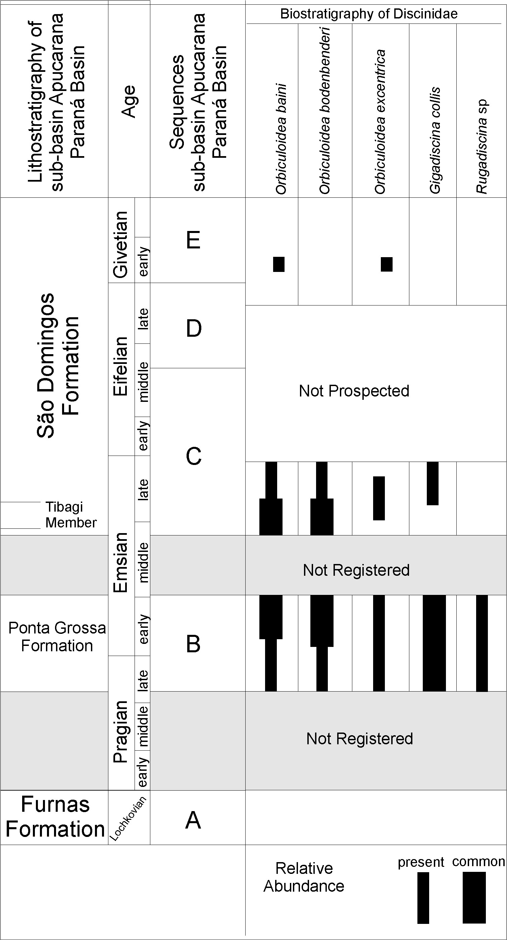

CONCLUSIONS

The adopted the reallocation of Orbiculoidea collis to Gigadiscina collis. Lange’s (1943) species Orbiculoidea excentrica, regardless of being proposed based only on one valve and not being cited in any other paper until now, does not represent a taphotaxon. Gigadiscina collis, Orbiculoidea baini, Orbiculoidea excentrica, Orbiculoidea bodenbenderi and Rugadiscina stagona represent the Devonian discinoids from the Paraná Basin. Devonian discinoids from the Paraná Basin, Paraná state, are considered epibenthonic and sessile. They can occur isolated (Gigadiscina collis and O. bodenbenderi) or in clusters (Orbiculoidea baini, O. bodenbenderi and O. excentrica).
The five discinoid species lived at the same region, during the late Pragian to early Emsian, associated with other invertebrates; this characterizes the climax of the Malvinokaffric Realm during Lower Devonian. Orbiculoidea baini and O. excentrica had the widest paleogeographic and stratigraphic distribution. They occurred from the late Pragian to early Givetian. The specie O. excentrica is the least common species. O. bodenbenderi is the second in abundance and occurrence. It occurred during the late Pragian and disappeared at the early Emsian, before the Middle Devonian Kačák Event. From the late Emsian, the discinoid fauna began to decline in terms of abundance and distribution, and Gigadiscina collis disappeared from the paleontological record along with other Malvinokaffric representatives.

ACKNOWLEDGEMENTS

JC Comniskey thanks to UEPG and Dr. Luiz Eduardo Anelli (USP-SP) for assistance in the preparation of images. EP Bosetti thanks to Conselho Nacional de Desenvolvimento Científico e Tecnológico (CNPq PQ 401796/2010-8) for financial support. We thank Jorge Villegas Martín (PPGEO- Unisinos) for translating the abstract into Spanish. Thanks also to Dr. Leonardo Borghi (UFRJ) for his help in Latinizing the name of the new species of discinoid. Dr. Rodrigo S. Horodyski (UNISINOS) for support at work.

REFERENCES
BERGAMASCHI, Sergio. Análise estratigráfica do Siluro-Devoniano (Formações Furnas e Ponta Grossa) da sub-bacia de Apucarana, Bacia do Paraná, Brasil. 1999. Ph. D. thesis. Instituto de Geociências, Universidade de São Paulo, São Paulo, Brazil.
BERGAMASCHI, Sergio; PEREIRA Egberto. Caracterização de sequências deposicionais de 3º ordem para o Siluro-Devoniano na sub-bacia de Apucarana, Bacia do Paraná, Brasil. Ciência-Técnica-Petróleo. Seção Exploração de Petróleo, v. 20, p. 63-72, 2001.
BOSETTI, Elvio Pinto; HORODYSKI, Rodrigo Scalise; ZABINI, Carolina; MATSUMURA, William Mikio Kurita; PENTEADO, Andressa Carla. Ocorrência de fenótipos subnormais no topo da Formação Ponta Grossa (Devoniano), Tibagi, estado do Paraná, Brasil: implicações tafonômicas e Paleossinecológicas. Boletim do Museu Paraense Emílio Goeldi, v. 5, n. 2, p. 135-149, 2010a.
BOSETTI, Elvio Pinto; HORODYSKI, Rodrigo Scalise; ZABINI, Carolina; MATSUMURA, William Mikio Kurita; GODOY, Luiz Carlos. Ocorrência de Lingulepis (Brachiopoda - Obolidae) na Formação Ponta Grossa, Devoniano, Estado do Paraná, Brasil. Boletim do Museu Paraense Emílio Goeldi, v. 5, n. 2, p. 151-164, 2010b.
BOSETTI, Elvio Pinto; GRAHN, Yngve Carl; HORODYSKI, Rodrigo Scalise; MENDLOWICZ MAULLER, Paula; BREUER, Pierre; ZABINI, Carolina. An earliest Givetian Lilliput Effect in the Paraná Basin, and the collapse of the Malvinokaffric shelly fauna. Palaeontologische Zeitschrift, v. 85, n. 1, p. 49-65, 2011.
BOSETTI, Elvio Pinto; GRAHN, Yngve; HORODYSKI, Rodrigo Scalise; MENDLOVICZ MAULLER, Paula. The first recorded decline of the Malvinokaffric Devonian fauna in the Paraná Basin (southern Brazil) and its cause; taphonomic and fossil evidences. Journal of South American Earth Sciences, v. 37, p. 228-241, 2012.
BOUCOT, Arthur J.; ROWELL, Albert J.; RACHEBOEUF, Patrick; PEREIRA, Egberto; MELO, José Henrique Gonçalves; SIQUEIRA, Luiz Peixoto. Position of the Malvinokaffric Realm’s northern boundary (Early Devonian) based on newly discovered brachiopods from the Parecis Basin (Brazil). Journal of the Czech Geological Society, v. 46, p. 109-120, 2001.
BRETT, Carlton E; BAIRD, Gordon C. Comparative taphonomy: a key for paleoenvironmental reconstruction. Palaios, v. 1, p. 207-227,1986.
CLARKE, John Mason. Fósseis Devonianos da Bacia do Paraná. Monographias do Serviço Geológico e Mineralógico do Brasil.1913.
COMNISKEY, Jeanninny Carla. Paleontologia dos Discinidae (Brachiopoda: Linguliformea) da sucessão devoniana da Bacia do Paraná, Estado do Paraná, Brasil: Revisão Sistemática, distribuição geográfica e estratigráfica. Masters Dissertation. Programa de Pós – Graduação em Geografia, Universidade Estadual de Ponta Grossa, Paraná, Brazil. 2011.
COMNISKEY, Jeanninny Carla; BOSETTI, Elvio Pinto. Novo Discinídeo do Devoniano da Bacia do Paraná, Estado do Paraná, Brasil. In: VII REUNIÃO ANUAL DA SOCIEDADE BRASILEIRA DE PALEONTOLOGIA PR/SC, p. 27, 2012, Mafra. ANAIS PALEONTOLOGIA EM DESTAQUE, Mafra, 2012. p. 26-27.
EMIG, Christian C. Ecology of the inarticulated brachiopods. 497-502. In: KAESLER, Roger L. Treatise on Invertebrate Paleontology: Part H. Brachiopoda (revised). Geological Society of America and University of Kansas, Boulder, Colorado and Lawrence, Kansas, v.1, 1997.
GAUGRIS, Kariny A.; GRAHN, Carl Yngve. New chitinozoan species from the Devonian of the Paraná basin, south Brazil, and their biostratigraphic significance. Ameghiniana, v. 43, p. 293-310, 2006.
GODOY, Luiz Carlos; BOSETTI, Elvio Pinto; HORODYSKI, Rodrigo Scalise. Icnitos do gênero Zoophycos na sequência devoniana da Bacia do Paraná, Ponta Grossa, Paraná, Brasil. IN: VII REUNIÃO ANUAL DA SOCIEDADE BRASILEIRA DE PALEONTOLOGIA PR/SC, 2005, ANAIS PALEONTOLOGIA EM DESTAQUE, 2005.
GRAHN, Carl Yngve; PEREIRA, Egberto; BERGAMASCHI, Sergio. Silurian and Lower Devonian chitinozoan biostratigraphy of the Paraná Basin in Brazil and Paraguay. Palynology, v. 24; p. 147-176, 2000.
GRAHN, Carl Yngve; MENDLOVICZ MAULLER, Paula; BREUER, Pierre; BOSETTI, Elvio Pinto; BERGAMASCHI, Sergio; PEREIRA, Egberto. The Furnas/Ponta Grossa contact and the age of the lowermost Ponta Grossa Formation in the Apucarana Sub-basin (Paraná Basin, Brazil): integrated palynological age determination. Revista Brasileira de Paleontologia, v. 13, p. 89-102, 2010.
GRAHN, Carl Yngve; MENDLOWICZ MAULLER, Paula; BERGAMASCHI, Sergio; BOSETTI, Elvio Pinto. Palynology and sequence stratigraphy of three Devonian rock units in the Apucarana Sub-basin (Paraná Basin, south Brazil): Additional data and correlation. Paleobotany and Palynology, v. 198, p. 27-44, 2013.
HORODYSKI, Rodrigo Scalise; HOLZ, Michel; GRAHN, Carl Yngve; BOSETTI, Elvio Pinto. Remarks on the sequence stratigraphy and taphonomy of the Malvinokaffric fauna during the Kacák event in the Apucarana Sub-basin (Paraná Basin), Brazil. International Journal of Earth Sciences, v.103; p. 367-380, 2014.
HORODYSKI, Rodrigo Scalise. Análise tafonômica, bioestratigráfica e paleoambiental dos invertebrados marinhos da Região De Tibagi-PR (Devoniano Inferior e Médio da Bacia do Paraná). 2014. Ph. D. thesis. Instituto de Geociências, Universidade Federal do Rio Grande do Sul, Rio Grande do Sul, Brazil.
HOUSE, Michael R. Strength, timing and cause of mid- Palaeozoic extinctions. Paleogeography Paleoclimatology Paleoecology, v. 181, p. 5–25, 2002.
KIDWELL, Susan M.; FURISCH, Franz T.; AIGNER, Thomas. Conceptual framework for the analysis and classification of fossil concentrations. Palaios, v. 1,p. 228-238, 1986.
KIDWELL, Susan M.; HOLLAND, Steven M. Field description of coarse bioclastic fabrics. Palaios, v. 6, p. 426-434,1991.
KOZLOWSKI, Roman. Fósiles Dévoniensis de l’ état de Paraná (Brésil). Annales de Paleontologie Paris, v. 8, n. 3, p. 1-19, 1913.
LANGE, Frederico Waldemar. Novos Fósseis devonianos do Paraná. Arquivos do Museu Paranaense, v. 3, p. 223-225, 1943.
LANGE, Frederico Waldemar. Paleontologia do Paraná: volume comemorativo do 1º Centenário do Estado do Paraná. Comissão de Comemorações do Centenário do Paraná. 1954.
LECH, Roberto Ricardo. A review of Orbiculoidea saltensis Reed, Brachiopoda: Discinidae, of the Upper Carboniferous of Argentina. Serie Correlación Geológica, v. 27, n. 1, p. 07-16, 2011.
LUCAS, Spencer G. Taphotaxon. Lethaia, v. 34, n. 1, p. 30, 2001.
MELO, Jose Henrique Gonçalvez. The Malvinokaffric realm in the Devonian of Brazil. In: MCMILLAN, N.J., EMBRY, A. F., & GLASS, D.J. (Eds.) Devonian of the World, Canadian Society of Petroleum Geologists Memoires, v. 1, n. 14, p. 669-703, 1988.
MENDLOWICZ MAULLER, Paula; GRAHN, Carl Yngve; MACHADO CARDOSO, Tereza R. Palynostratigraphy from the Lower Devonian of the Paraná Basin, south Brazil, and a revision of contemporary chitinozoan biozones from western Gondwana. Stratigraphy, v. 6, p. 313-332, 2009.
MERGL, Michal. Lingulate brachiopods of the Silurian and Devonian of the Barrandian. Acta Museinationalis Pragae, Series B – Historia Naturalis, v. 57, n. 1/2, p. 1–49, 2001.
MERGL, Michal; MASSA, Dominique. A new giant discinoid brachiopod from the Lower Devonian of Algeria. Acta PalaeontologicaPolonica, v. 50, n. 2, p. 397–402, 2005.
MERGL, Michal. Discinid brachiopod life assemblages: Fossil and extant. Bulletin of Geosciences, v. 85, n. 2, p. 27- 38, 2010.
MILANI, Edison Jose; MELO, Jose Henrique G.; SOUZA, Paulo Alvez FERNANDES, Luiz Alberto; FRANÇA, Amerio Barros. Bacia do Paraná. Boletim de Geociências da Petrobrás, v. 15, p. 265-287, 2007.
REINECK, HANS ERICH. Sedimentgefügeim Bereich der südlichen Nordsee. Abhandlungen der Senckenbergischen Naturfoschenden Gesellschaft, v. 505, p. 1–138, 1963.
SIMÕES, Marcelo G.; KOWALESKI, Michal; TORELLO, Fernanda F.; GHILARDI, Renato Pirani. Devonian and Permian benthic marine invertebrate preserved in life position: taphonomic feedback in a Paleozoic eperic sea. In: XVI CONGRESSO BRASILEIRO DE PALEONTOLOGIA, 1999, Crato, CE, Boletim de Resumos, p. 109-110, 1999.
SIMÕES, Marcelo G.; GHILARDI, Renato Pirani. Protocolo tafonômico/paleoautoecológico como ferramentas nas análises paleossinecológicas de invertebrados: exemplos de aplicação em concentrações fossilíferas do Paleozóico da Bacia do Paraná, Brasil. Pesquisas em Geociências, v. 27, n. 2, p. 3-13, 2000.
SPEYER, Stephen E.; BRETT, Carlton E. Taphofacies models for epeiric sea environments: Middle Paleozoic examples. Palaeogeography, Palaeoclimatology, Palaeoecology, v. 63, n. 1, p. 225-262, 1988.
SÜDKAMP, W. H. Discovery of soft parts of a fossil brachiopod in the “Hunrsücksciefer” (Lower Devonian, Germany). Paläontologische Zeitschrift, v. 71, n. 1/2, p. 91- 95, 1997.
WILLIAMS, Alwyn; ROWELL, Albert J. Introduction. 1-5. In: MOORE, Raymond C. (Ed.). TREATISE ON INVERTEBRATE PALEONTOLOGY. PART H, BRACHIOPODA, AND VOLUME 1. The Geological Society of America and University of Kansas Press, Lawrence, 1997.
ZABINI, Carolina; BOSETTI, Elvio Pinto; HOLZ, Michel. Taphonomy and taphofacies analysis of lingulid brachiopods from Devonian sequences of the Paraná Basin, Brazil. Palaeogeography, Palaeoclimatology, Palaeoecology, v. 292, p. 44-56, 2010.
ZABINI, Carolina; COMNISKEY, Jeanninny Carla; BOSETTI, Elvio Pinto. John Mason Clarke e os lingulídeos e discinídeos dos estratos devonianos da Bacia do Paraná, estado do Paraná, Brasil: estado da arte. Terr@ Plural, v.7, n. 43-58, 2013.

