- Cymbella tumida (Brébisson ex Kützing) Van Heurck var. tumida
- Cymbopleura naviculiformis (Auerswald ex Heiberg) K. Krammer
- Encyonema neogracile Krammer
- Encyonema angustecapitatum Krammer
- Encyonema neomesianum Krammer
- Encyonema perpusilum (A. Cleve) D.G. Mann
- Encyonema silesiacum (Bleisch) D.G. Mann
- Encyonema sp
- Encyonopsis kaingensis (Vyverman) Krammer
- Encyonopsis sp
- Placoneis disparilis (Hustedt) Metzeltin & Lange-Bertalot
- Placoneis exigua (Gregory) Mereschkowsky
- Gomphonema turris Ehrenberg
- Gomphonema brasiliense Grunow
- Gomphonema capitatum Ehrenberg
- Gomphonema clevei Fricke var. inaequilongum H. Kobayasi
- Gomphonema gracile Ehrenberg
- Gomphonema laticollum Reichardt
- Gomphonema parvulum (Kützing) Kützing
- Gomphonema lagenula Kützing
- Gomphonema pseudoaugur Lange-Bertalot
- Gomphonema subtile Ehrenberg
- Amphipleura lindheimerii Grunow
- Frustulia vulgaris (Thwaites) De Toni
- Frustulia crassinervia (Brébisson) Lange-Bertalot e Krammer
- Frustulia saxonica Rabenhorst
- Diadesmis contenta (Grunow ex Van Heurck) D.G. Mann
- Luticola dapalis (Frenguelii) D.G. Mann
- Luticola goeppertiana (H.L. Smith) D.G. Mann
- Luticola mutica (Kützing) D.G. Mann
- Luticola muticoides (Hustedt) D.G. Mann
- Luticola undulata (Hilse) D.G. Mann
- Neidium affine (Ehrenberg) Pfitzer
- Neidium catarinense (Krasske) Lange-Bertalot
- Amphora ovalis (Kützing) Kützing

1 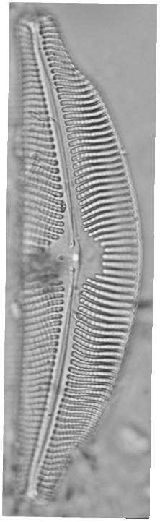 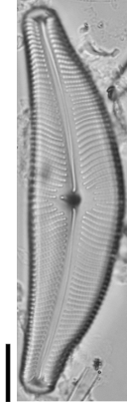 2 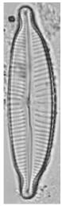 3 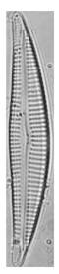 4 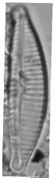
5 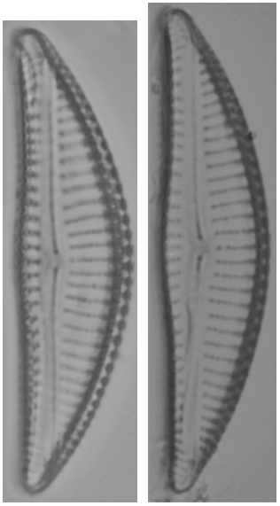 6 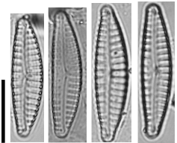
7 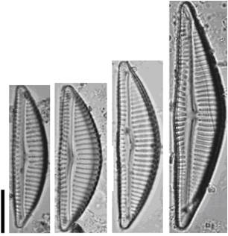 8 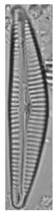 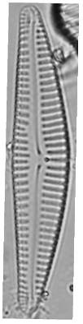 9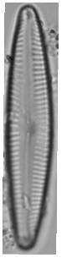 10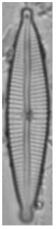
11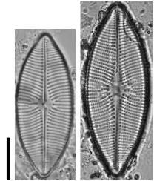 12 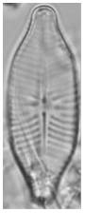 13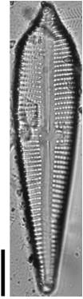 14 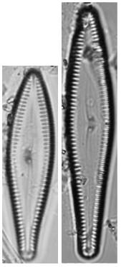 15 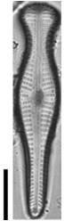 16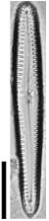 17 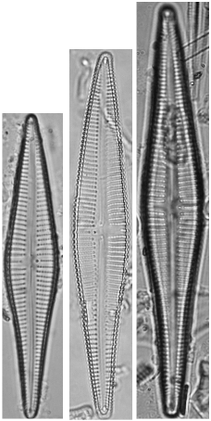 18 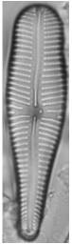 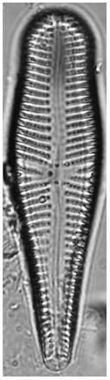
19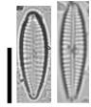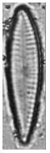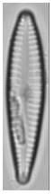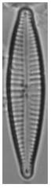 20 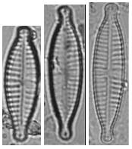 21 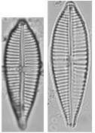 22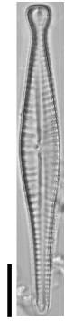 23 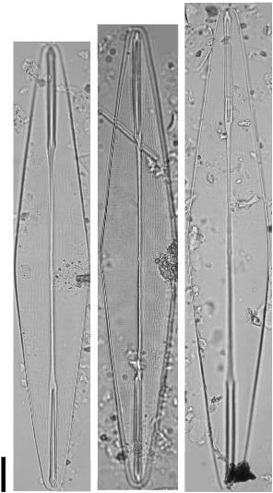 24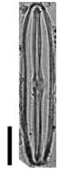 25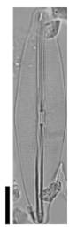 26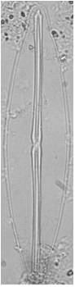
27 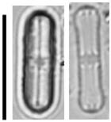 28 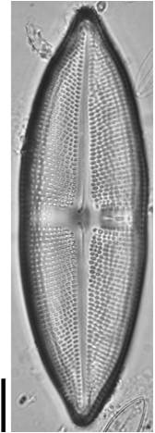 29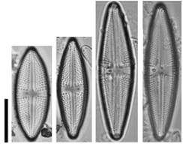
30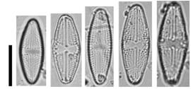 31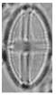 32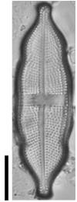
33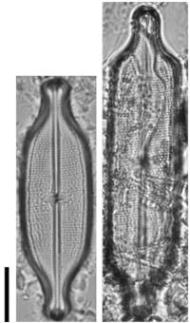 34 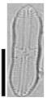 35